**TRAFFIC MANAGEMENT SYSTEM USING**

**YOLO**

**DESIGN PROJECT REPORT**

**Submitted by**

**K. Harish Kumar - 99220040566**

**V. Venkata Pavan Kumar - 99220041592**

**D. Khasim Aman - 99220040496**

**K. Sai - 99220040622**

**M. Mugesh Kannan - 9923005008**

**In partial fulfilment for the award of the degree of**

**BACHELOR OF TECHNOLOGY**

**IN**

**COMPUTER SCIENCE AND ENGINEERING**



**SCHOOL OF COMPUTING**

**COMPUTER SCIENCE AND ENGINEERING**

**KALASALINGAM ACADEMY OF RESEARCH**

**AND EDUCATION**

**KRISHNANKOIL 626 126**

November 2024

**DECLARATION**

We affirm that the project work titled **“TRAFFIC MANAGEMENT SYSTEM USING YOLO”** being submitted in partial fulfilment for the award of the degree of **Bachelor of Technology in Computer Science and Engineering** is the original work carried out by us. It has not formed part of any other project work submitted for the award of any degree or diploma, either in this or any other University.

K. Harish Kumar

99220040566

V. Venkata Pavan Kumar

99220041592

D. Khasim Aman

99220040496

M. Sai

99220040622

M. Mugesh Kannan

9823005008

This is to certify that the above statement made by the candidate is correct to the best of my knowledge.

Date:

Signature of supervisor

**Dr. M. K. Nagarajan**

**Associate Professor**

**Department of Computer Science and Engineering**



**BONAFIDE CERTIFICATE**

Certified that this project report **“TRAFFIC MANAGEMENT SYSTEM USING YOLO”** is the bonafide work of **“K. HARISH KUMAR (99220040566), V. VENKATA PAVAN KUMAR (99220041592), D. KHASIM AMAN (9220040496), M. SAI (99220040622), M. MUGESH KANNAN (9923005008)”** who carried out the project work under my supervision.

|  |  |
| --- | --- |
| **S. Rajesh** | **Dr. N. Suresh Kumar** |
| **Department of Mech** | **HEAD OF THE DEPARTMENT** |
| **Associate Professor** | **Professor & Head** |
| Mechanical Department | Computer Science and Engineering |
| Kalasalingam Academy of Research and Education | Kalasalingam Academy of Research and Education |
| Krishnankoil 626126 | Krishnankoil 626126 |
| Virudhunagar District. | Virudhunagar District. |

Submitted for the Project final review and Viva-voce held on …………………….

**Internal Examiner External Examiner**

**ACKNOWLEDGEMENT**

We would like to begin by expressing our heartfelt gratitude to the Supreme Power for the immense grace that enabled us to complete this project.

We are deeply grateful to the late **"Kalvivallal" Thiru T. Kalasalingam,** Chairman of the Kalasalingam Group of Institutions, and to "**Illayavallal" Dr. K. Sridharan**, Chancellor, as well as **Dr. S. Shasi Anand**, Vice President, who has been a guiding light in all our university’s endeavours.

Our sincere thanks go to our Vice Chancellor, **Dr. S. Narayanan**, for his inspiring leadership, guidance, and for instilling in us the strength and enthusiasm to work towards our goals.

We would like to express our sincere appreciation to **Dr. P. Deepa Lakshmi**, Professor & Dean-(SoC), Director Accreditation & Ranking, for her valuable guidance. Our heartfelt gratitude also goes to our esteemed Head of Department, **Dr. N. Suresh Kumar**, whose unwavering support has been crucial to the successful advancement of our project.

We are especially thankful to our Project Supervisor, **S. Rajesh**, for her patience, motivation, enthusiasm, and vast knowledge, which greatly supported us throughout this work.

Our sincere gratitude also goes to overall exsel Coordinators, for their constant encouragement and support in completing this Exsel Project.

Finally, we would like to thank our parents, faculty, non-teaching staff, and friends for their unwavering moral support throughout this journey.



**SCHOOL OF COMPUTING**

**COMPUTER SCIENCE AND ENGINEERING**

**PROJECT SUMMARY**

|  |  |  |
| --- | --- | --- |
| Project Title | TRAFFIC MANAGEMENT SYSTEM USING YOLO | |
| Project Team Members (Name with Register No) | K. Harish Kumar - 99220040566  V. Venkata Pavan Kumar - 99220041592  D. Khasim Aman - 99220040496  K. Sai - 99220040622  M. Mugesh Kannan - 9923005008 | |
| Guide Name/Designation | Dr.M.K. Nagarajan, Associate Professor, Department of Computer Science and Engineering, Kalasalingam Academy of Research and Education | |
| Program Concentration Area | Project focuses on real-time vehicle detection, traffic density classification, and pothole identification for road safety and control road flow with traffic light | |
| Technical Requirements | Project involves using deep learning models | |
| Engineering standards and realistic constraints in these areas | | |
| **Area** | **Codes & Standards / Realistic Constraints** | **Tick** ✓ |
| Economic | Cost-effective deployment and maintenance |  |
| Environmental | Reducing traffic congestion and emissions |  |
| Social | Improving road safety and traffic efficiency |  |
| Ethical | Ensuring privacy and data protection |  |
| Health and Safety | Enhancing safety through pothole detection |  |
| Manufacturability | Scalability and integration of models |  |
| Sustainability | Long-term maintenance and system upgrades |  |

**ABSTRACT**

AI-powered transportation systems are revolutionizing urban mobility management by leveraging real-time data processing, machine learning, and infrastructure communication to create a more interconnected, efficient, and sustainable urban environment. By analysing traffic volumes, patterns, and congestion points in real time, these systems dynamically adjust traffic flow to reduce idle times, fuel consumption, and emissions. This leads to smoother commutes, less traffic congestion, and more predictable travel times. A major benefit of AI in traffic management is enhanced safety, especially at intersections. Advanced object detection and risk analysis capabilities allow these systems to identify and respond swiftly to potential hazards, minimizing accidents and prioritizing emergency vehicles. The “Green Corridor” feature, for example, automatically clears pathways for emergency vehicles by adjusting traffic signals, which can be crucial for saving lives during critical situations. Furthermore, the reduction in idling times aligns with environmental sustainability goals by decreasing fuel consumption and emissions, making cities greener and more eco-friendly.

Beyond the environmental and safety benefits, AI-driven traffic systems positively impact economic productivity. Reduced commute times and efficient traffic flow mean that goods and people move faster through urban areas, which decreases both time and costs associated with traffic delays. The adaptability of these AI systems is also noteworthy; as they continuously learn from historical and real-time data, they can respond to unexpected events, such as road closures or accidents, to maintain optimal traffic flow. Additionally, vehicle-to-infrastructure communication enhances the system's functionality by providing drivers with personalized route recommendations, optimized traffic signal timings, and alternative paths to avoid congestion. This interconnected framework is essential for managing complex traffic patterns and meeting the demands of growing urban populations.

The integration of camera-based monitoring further strengthens AI-powered traffic systems by providing real-time visual data. This enables precise detection of vehicle types, pedestrian movements, and congestion levels, which not only improves decision-making but also helps in identifying high-traffic or accident-prone areas.

**TABLE OF CONTENTS**

|  |  |  |
| --- | --- | --- |
| **TITLE** | | **PAGE NO.** |
| **ABSTRACT** | | **6** |
| **LIST OF TABLES** | | **8** |
| **LIST OF FIGURES** | | **9** |
| **LIST OF ABBERIVATION** | | **10** |
| **CHAPTER I** | **INTRODUCTION** | **11** |
| **CHAPTER II** | **LITERATURE REVIEW** | **12-13** |
| **CHAPTER III** | **PROBLEM DEFINITION AND PROJECT OBJECTIVES** | **14-15** |
| **CHAPTER IV** | **PROPOSED METHODOLOGY** | **16-17** |
| **CHAPTER V** | **REQUIREMENTS AND MODULE DESCRIPTION** | **18-20** |
| **CHAPTER VI** | **SYSTEM IMPLEMENTATION** | **21-26** |
| CHAPTER VII | RESULTS AND DISCUSSION | **27-30** |
| CHAPTER VIII | COMMUNITY IMPACT | **31-32** |
| **CHAPTER IX** | **CONCLUSION AND FUTURE SCOPE** | **33-34** |
| **REFERENCES:** List of books, articles, research papers, and other resources used | | **35** |
| **Proof of Submitted Paper/Filed Patent (If Any)** | | |
| **Certification (If Any)** | | |
| **Plagiarism Report** | | |

**LIST OF TABLES**

|  |  |  |
| --- | --- | --- |
| **TABLES** | **DETAILS** | **PAGE NO** |
| **Table 1** | Literature Review | 13 - 14 |

**LIST OF FIGURES**

|  |  |  |
| --- | --- | --- |
| **FIGURES** | **DETAILS** | **PAGE NO.** |
| Fig.1 | Flow Chart | 17 |
| Fig.2 | System Architecture | 28 |
| Fig.3 | App Introduction | 28 |
| Fig.4 | Pothole detection | 29 |
| Fig.5 | Traffic Density Classification | 29 |
| Fig.6 | Vehicle Category Detection | 30 |
| Fig. 7 | Prototype | 30 |

**LIST OF ABBERIVATION**

**TRM** - Traffic Management System

**YOLO** - You Look Only Once

**CHAPTER –I**

**INTRODUCTION**

Achieving a more precise and adaptive estimate of green signal time is essential for optimizing traffic flow and minimizing delays in metropolitan areas. This approach employs advanced object detection algorithms, such as YOLO (You Only Look Once), to categorize and quantify vehicles in real time. By accurately identifying and counting vehicles in each direction, the system gathers critical data on traffic volume and distribution at intersections. Classifying vehicles into distinct categories allows for a more refined understanding of the traffic mix, accounting for varying vehicle sizes, speeds, and acceleration rates.

Once the real-time data is obtained, the system becomes adaptive, dynamically adjusting traffic signal timers based on the volume and category of vehicles in each direction. This flexibility sets it apart from traditional, static traffic systems by responding to actual traffic conditions rather than relying on predetermined schedules. By tailoring green signal durations to current traffic needs, the system minimizes unnecessary delays, leading to faster clearance of intersections and reduced congestion.

The adaptive signal adjustment also brings environmental benefits. Reduced waiting times and smoother traffic flow lower fuel consumption and emissions, contributing to a more sustainable urban transportation system. Vehicles spend less time idling, which not only improves fuel efficiency but also aligns with broader environmental goals by reducing air pollution.

In summary, this system's integration of object detection and adaptive signal timing based on real-time data presents an advanced solution to traffic management. By leveraging technology to monitor, categorize, and respond to traffic conditions dynamically, it enhances traffic efficiency, reduces congestion, conserves fuel, and promotes a cleaner, more sustainable urban environment.

In the dense, fast-paced environments of metropolitan cities, achieving an optimal and adaptive estimate of green signal time is essential for maintaining efficient traffic flow and reducing delays. A cutting-edge solution involves segmenting vehicles into distinct categories while leveraging advanced object detection technologies, such as YOLO (You Only Look Once), to capture real-time data on traffic dynamics.

**CHAPTER-II**

**LITERATURE REVIEW**

|  |  |  |  |  |
| --- | --- | --- | --- | --- |
| **S.NO** | **TITLE** | **AUTHOR** | **YEAR** | **DESCRIPTION** |
| **1.** | Road Traffic Condition Monitoring using Deep Learning. | 1. A. Alsharif, M. A. Alsharif, and M. A. Alsharif | 2022 | This paper surveys the recent studies on bike sharing usage prediction using deep learning techniques. It also analyzes the challenges and opportunities in this domain. |
| **2.** | Smart Traffic Management System Using Internet of Things | Sabeen Javaid, Ali Sufian, Saima Pervaiz, Mehak Tanveer | 2018 | managing traffic on roads and to help authorities in proper planning, a smart traffic management system using the Internet of Things. |
| **3.** | A Survey on Urban Traffic Management System Using Wireless Sensor Networks. | Kapil Eswar Nellore and Gerhard P. Hancke . | 2015 | Reducing congestion and the AWT of vehicles. The main objective of this survey is to provide a taxonomy of different traffic management schemes used for avoiding congestion. |

|  |  |  |  |  |
| --- | --- | --- | --- | --- |
| **S.NO** | **TITLE** | **AUTHOR** | **YEAR** | **DESCRIPTION** |
| **4.** | Intelligent eco-friendly transport management system | p.Ajay, B.Nagaraj,Barnesh Madhavan pillai , jackrit suthakorn , M.Bardha | 2022 | Utilizes advanced algorithms to analyze real-time traffic data and make intelligent decisions. These decisions can include optimizing traffic signal timings. |
| **5.** | Smart Traffic Management System using Deep Learning  for Smart City  Applications. | Guy M. Lingani,  DandaB.Rawat,  Moses Garuba. | 2019 | Created based upon series of algorithms modeled after the human brain, our system uses NVIDIA video cards with GPU, CUDA, OPEN CV and mathematical vectors systems to perform. |
| **6.** | Smart Control of Traffic Light Using Artificial Intelligence | Mihir M. Gandhi,  Devansh S. Solanki,  Rutwij S. Daptardar,  Nirmala Shinde Baloorkar | 2020 | potential benefits of such a system in terms of improved traffic management, reduced environmental impact, and enhanced user experience. |

**CHAPTER-III**

**PROBLEM DEFINITION AND PROJECT OBJECTIVES**

**Problem Definition:**

Traffic congestion is one of the most pressing issues faced by metropolitan cities worldwide. With the rapid growth of urban populations and the increasing number of vehicles on the road, traditional traffic management systems are becoming less effective. These conventional systems, which often rely on fixed signal timings, struggle to adapt to varying traffic volumes and patterns. This lack of adaptability leads to multiple challenges, including:

1. **Increased Traffic Congestion**: Fixed-timed signals do not account for real-time traffic conditions, resulting in vehicles idling at intersections longer than necessary. This inefficiency leads to bottlenecks and heavy congestion, particularly during peak hours.
2. **Longer Commute Times**: Due to inefficient traffic signal management, commuters experience increased travel times. This loss of time affects productivity, increases stress levels, and impacts the overall quality of life for urban residents.
3. **Higher Fuel Consumption and Emissions**: Prolonged idling and frequent stops contribute to excessive fuel consumption and increased emissions. This not only raises the cost for individual commuters but also has a detrimental impact on the environment, contributing to pollution and climate change.

**Objectives:**

The primary objective of this project is to design and implement an AI-powered Smart Traffic Signal Management System that addresses the limitations of traditional traffic management and enhances urban mobility. The following objectives outline the specific goals of the project:

1. **Real-Time Adaptive Signal Control**:
   * Develop a system that dynamically adjusts traffic signal timings based on real-time data, including vehicle volume, traffic density, and road conditions.
   * The system should be able to respond instantaneously to changing traffic conditions, minimizing delays and reducing congestion.
2. **Advanced Vehicle Detection and Categorization**:
   * Implement advanced object detection algorithms, such as YOLO (You Only Look Once), to accurately identify, classify, and count different types of vehicles (e.g., cars, trucks, buses, motorcycles) in real time.
   * This categorization will allow for tailored signal timing adjustments, ensuring that larger vehicles with slower acceleration are managed differently from smaller, faster vehicles.
3. **Prioritization of Emergency Vehicles**:
   * Integrate a mechanism for detecting and prioritizing emergency vehicles (e.g., ambulances, fire trucks, police vehicles) to create a “Green Corridor” that enables their swift passage through intersections.
   * This feature aims to reduce response times for emergency services, potentially saving lives in critical situations.

**CHAPTER-IV**

**PROPOSED METHODOLOGY**

The methodology section describes the methodical process followed in creating and executing the Traffic Management System with YOLO, such as the detection and classification of various vehicle categories, traffic density classification, and pothole object detection. For fulfilling the project goals, the following actions have been taken:

**1.Data gathering and preparation:**

The information ranges from photographs and videos that were classified based on type of vehicle, volume of traffic, and conditions on the road. Some of the materials accessed were open source and directly captured from dashcams and other sources that have publicly available feedings of traffic streams.

During the process of preprocessing, we resorted to resize the images to a standard resolution, augmented them with data, such as rotation and flipping, for further abstraction, and annotated different objects for object detection, like detecting cars and potholes.

***2.*Choosing and Training Models:**

**a. Identification and Classification of Vehicle Categories:**

Using a YOLO architecture was chosen for real-time vehicle detection and classification.

With PyTorch and TorchVision, the model was trained on the annotated dataset. During the training process, the model was optimized using methods such as gradient descent and convergence-checking hyperparameters..

**b. Classification of Traffic Density:**

In order to categorize traffic into categories such as Empty, Low, Medium, High, or Traffic Jam.This model was trained using the PyTorch framework, with data augmentation and fine-tuning to achieve high accuracy, much like the vehicle category classification model.

**c. Identifying Pothole Objects:**

Using a YOLO was used for pothole detection.Pothole-filled annotated photos were used to train the model, and recall and precision were optimized during training.

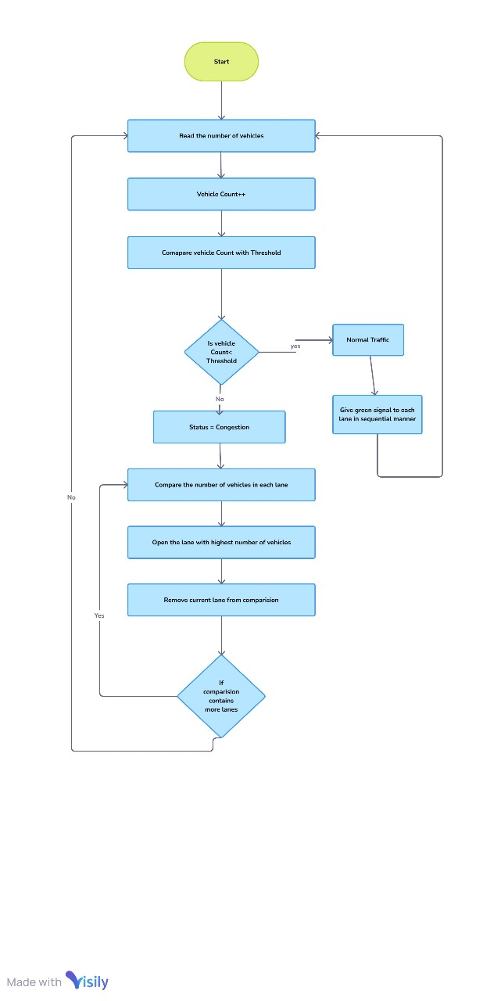

**Fig.1.Flow Chart**

**CHAPTER-V**

**REQUIREMENTS AND MODULE DESCRIPTION**

**Requirements: -**

**1.Hardware Needs**

* A high-speed GPU – e.g., NVIDIA RTX series – for training and inferencing the deep learning model.
* Computer System minimum:

CPU: Intel i5 or better

RAM: 8 GB minimum

Storage: 500 GB SSD

Cameras or dashcams for traffic live feeds.

**2. Software Needs**

* OS: Windows or Linux, preferably Ubuntu.
* Programming language: Python 3.x
* **Frameworks and Libraries:**

PyTorch, TorchVision for training and evaluation of the model.

OpenCV (for image and video processing)

Streamlit (for building the user interface)

Scikit-learn, NumPy, Pandas (for data preprocessing and metrics)

**3.Development Tools:**

* Jupyter Notebook / Visual Studio Code (for writing the code)
* Git/GitHub (for version control)

**Module Description: -**

The project modules may thus be summarized as follows:

1. **Data Collection and Preprocessing Mo**
2. **dule**

* **Description:** It covers the acquisition of raw data through images and videos using dashcams and from open sources; this module preprocesses data through resizing, normalization, augmentation, and annotation for training.
* **Key Functions:**

1. Load and preprocess images/videos
2. annotate objects (vehicles, potholes, etc.)
3. Data Augmentation Techniques Rotation and flipping

**2. Vehicle Detection and Classification Module**

* **Description:** This module focuses on vehicle detection and classification by using a deep learning model, mainly an YOLO
* **Key Functions:**
  + 1. It acts as the training mode of the YOLO model from the annotated vehicle datasets.
    2. It performs real-time vehicle and class detection from real-time video feeds that stream the videos created in order to monitor traffic.

**Output:** Classified vehicles along with their bounding boxes, including cars, trucks, and buses.

**3. Traffic Density Classification Module**

* **Description:** It classifies traffic density in real-time by categorizing it into classes (Empty, Low, Medium, High, Jam) making use of YOLO model.
* **Key Functions:**

1. Train the annotated datasets of traffic density in the YOLO model.
2. classify the traffic density in real-time
3. Evaluate model accuracy based on F1-score and Confusion matrix

**Output:** This system shows the level of traffic density in real-time

**4. Pothole Detection Module**

* **Description:** Pothole Detection on Roads using an object detection model YOLO Identify and draw bounding boxes around potholes to make roads safer
* **Key Functions:**

1. Train the model with images of potholes annotated Determine how to optimize recall and precision as the model is trained

* **Output**: drawing bounding boxes around potholes identified in video feed

**5. Integration and Inference Model**

* **Description:** The module integrates models of vehicle detection, traffic density classification, and pothole detection to work together in one unified system that makes efficient inference in real time.
* Key Functions:

1. Load pre-trained models
2. Integrate models to work together over real-time video streams
3. Optimize the overall system performance to ensure a smooth operation

**CHAPTER-VI**

**SYSTEM IMPLEMENTATION**

**Pothole Detection.py**

import streamlit as st

from PIL import Image

import cv2

import numpy as np

import os

import torch

from utils import get_pothole_model, detection_img

st.title("Pothole Object Detection")

classes = ["Background", "Pothole"]

dirname = os.path.dirname(os.path.abspath(__file__))

root_dir = os.path.join(dirname, os.pardir)

pothole_img_dir = os.path.join(root_dir, "images", "pothole_img")

model = get_pothole_model()

model.eval()

*# File uploader widget for uploading images*

file = st.file_uploader("Input Image File", type=['jpg', 'png', 'jpeg'])

*# Camera input widget for taking a photo*

camera_file = st.camera_input("Take a picture")

*# Slider widgets for setting confidence and IOU thresholds*

c1, c2 = st.columns(2)

with c1:

    conf_threshold = float(st.slider("Confidence Threshold", min_value=0.0, max_value=1.0, value=0.2, step=0.02))

with c2:

    iou_threshold = float(st.slider("IOU Threshold", min_value=0.0, max_value=1.0, value=0.7, step=0.02))

col1, col2 = st.columns(2)

button = st.button("Detect")

if button:

    if file is not None:

*# Image uploaded*

        title = "Uploaded Image"

        img = Image.open(file)

        img = np.array(img)

        img = cv2.resize(img, (480, 480))

    elif camera_file is not None:

*# Image taken from camera*

        title = "Captured Image"

        img = Image.open(camera_file)

        img = np.array(img)

        img = cv2.resize(img, (480, 480))

    else:

*# Default image if no file or camera input*

        title = "Default Image"

        idx = np.random.choice(range(4), 1)[0]

        default_img_path = os.path.join(pothole_img_dir, **f**"{idx}.png")

        img = Image.open(default_img_path)

        img = np.array(img)

        img = cv2.resize(img, (480, 480))

*# Display the images*

    with col1:

        st.write(title)

        st.image(img)

    with col2:

        st.write("Pothole Object Detection")

        detect_img = detection_img(model, img, classes, conf_threshold, iou_threshold)

        st.image(detect_img)

**Traffic Density classification.py**

import streamlit as st

from PIL import Image

import cv2

import numpy as np

import os

import torch

from utils import classify_img, get_density_model

st.title("Traffic Density Classification")

classes = ['Empty', 'High', 'Low', 'Medium', 'Traffic Jam']

model = get_density_model()

model.eval()

*# Directory paths for default images*

dirname = os.path.dirname(os.path.abspath(__file__))

root_dir = os.path.join(dirname, os.pardir)

density_img_dir = os.path.join(root_dir, "images", "density_img")

*# File uploader widget for uploading images*

file = st.file_uploader("Input Image File", type=['jpg', 'png', 'jpeg'])

*# Camera input widget for taking a photo*

camera_file = st.camera_input("Take a picture")

*# Button to start detection*

button = st.button("Detect")

if button:

    if file is not None:

*# Image uploaded*

        title = "Uploaded Image"

        img = Image.open(file)

        img = np.array(img)

        img = cv2.resize(img, (480, 480))

        label, probability = classify_img(model, img)

    elif camera_file is not None:

*# Image taken from camera*

        title = "Captured Image"

        img = Image.open(camera_file)

        img = np.array(img)

        img = cv2.resize(img, (480, 480))

        label, probability = classify_img(model, img)

    else:

*# Default image if no file or camera input*

        title = "Default Image"

        idx = np.random.choice(range(5), 1)[0]

        default_img_path = os.path.join(density_img_dir, **f**"{idx}.jpg")

        img = Image.open(default_img_path)

        img = np.array(img)

        img = cv2.resize(img, (480, 480))

        label, probability = classify_img(model, img)

*# Display the results*

    st.success(**f**"Predicted Class is {classes[label]} with probability {probability**:.4f**}")

    st.image(img, caption=title)

**Vehicle Category Detection.py**

import streamlit as st

from PIL import Image

import cv2

import numpy as np

import os

import torch

from utils import get_category_model, detection_img

st.title("Vehicle Category Detection")

classes = ["background", "Auto", "Bus", "Car", "LCV", "Motorcycle", "Truck", "Tractor", "Multi-Axle"]

model = get_category_model()

model.eval()

*# Directory paths for default images*

dirname = os.path.dirname(os.path.abspath(__file__))

root_dir = os.path.join(dirname, os.pardir)

category_img_dir = os.path.join(root_dir, "images", "category_img")

*# File uploader widget for uploading images*

file = st.file_uploader("Input Image File", type=['jpg', 'png', 'jpeg'])

*# Camera input widget for taking a photo*

camera_file = st.camera_input("Take a picture")

*# Slider widgets for setting confidence and IOU thresholds*

c1, c2 = st.columns(2)

with c1:

    conf_threshold = float(st.slider("Confidence Threshold", min_value=0.0, max_value=1.0, value=0.2, step=0.02))

with c2:

    iou_threshold = float(st.slider("IOU Threshold", min_value=0.0, max_value=1.0, value=0.6, step=0.02))

col1, col2 = st.columns(2)

button = st.button("Detect")

if button:

    if file is not None:

*# Image uploaded*

        title = "Uploaded Image"

        img = Image.open(file)

        img = np.array(img)

        img = cv2.resize(img, (480, 480))

    elif camera_file is not None:

*# Image taken from camera*

        title = "Captured Image"

        img = Image.open(camera_file)

        img = np.array(img)

        img = cv2.resize(img, (480, 480))

    else:

*# Default image if no file or camera input*

        title = "Default Image"

        idx = np.random.choice(range(7), 1)[0]

        default_img_path = os.path.join(category_img_dir, **f**"{idx}.jpg")

        img = Image.open(default_img_path)

        img = np.array(img)

        img = cv2.resize(img, (480, 480))

*# Display the images*

    with col1:

        st.write(title)

        st.image(img)

    with col2:

        st.write("Vehicle Category Detection")

        detect_img = detection_img(model, img, classes, conf_threshold, iou_threshold)

        st.image(detect_img)

**CHAPTER-VII**

**RESULTS AND DISCUSSION**

The implementation of a Smart Traffic Control Management System utilizing AI yields significant and multifaceted results, bringing about transformative changes in urban transportation dynamics. This section discusses the key outcomes and implications of integrating AI into traffic control. Optimized Traffic Flow and Reduced Congestion: One of the primary outcomes of the AI-powered system is the optimization of traffic flow. By dynamically adjusting signal timings based on real- time data, the system minimizes unnecessary stops and delays, leading to a smoother and more efficient traffic movement. Reduced congestion is a direct consequence, positively impacting the overall mobility of vehicles within the urban landscape.

**Decreased Commute Times and Enhanced Efficiency:**

The AI-driven system's adaptability and learning capabilities result in decreased commute times for both individual commuters and public transportation. Through continuous refinement of its algorithms, the system learns from traffic patterns, making informed decisions to maximize the efficiency of signal timings. This improvement not only benefits commuters but also enhances economic productivity by reducing time spent in transit.

**Environmental Benefits and Reduced Emissions:** The dynamic adjustments in traffic signal timings contribute to decreased idling times at intersections. This reduction in unnecessary stops translates to lower fuel consumption and, consequently, reduced emissions. The environmental impact of the AIpowered system aligns with sustainability goals, fostering a greener and more eco-friendly urban environment.

**Improved Safety Features:** The integration of AI enhances safety features within the traffic management system. Real-time object detection and hazard identification enable quick responses to potential dangers at intersections. The system's ability to prioritize emergency vehicles ensures rapid clearance, potentially preventing accidents and saving lives in critical situations. Overall, the AI system contributes to a safer urban transportation infrastructure.

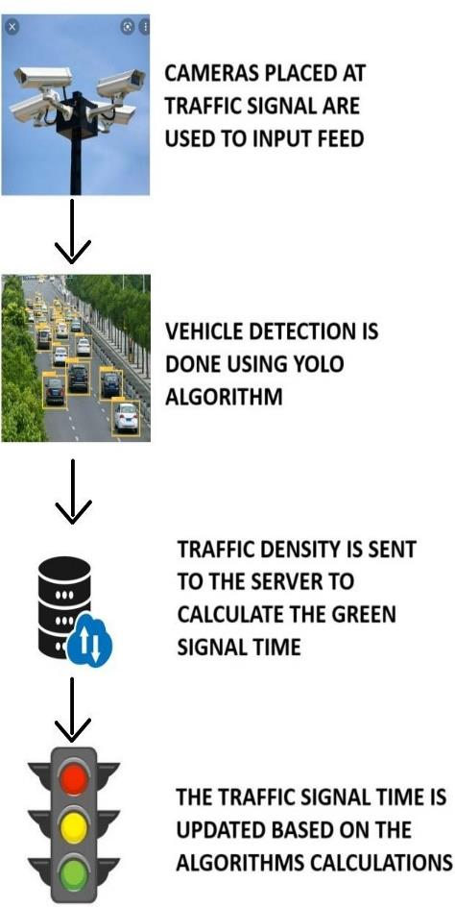

**Fig. 2. System Architecture**

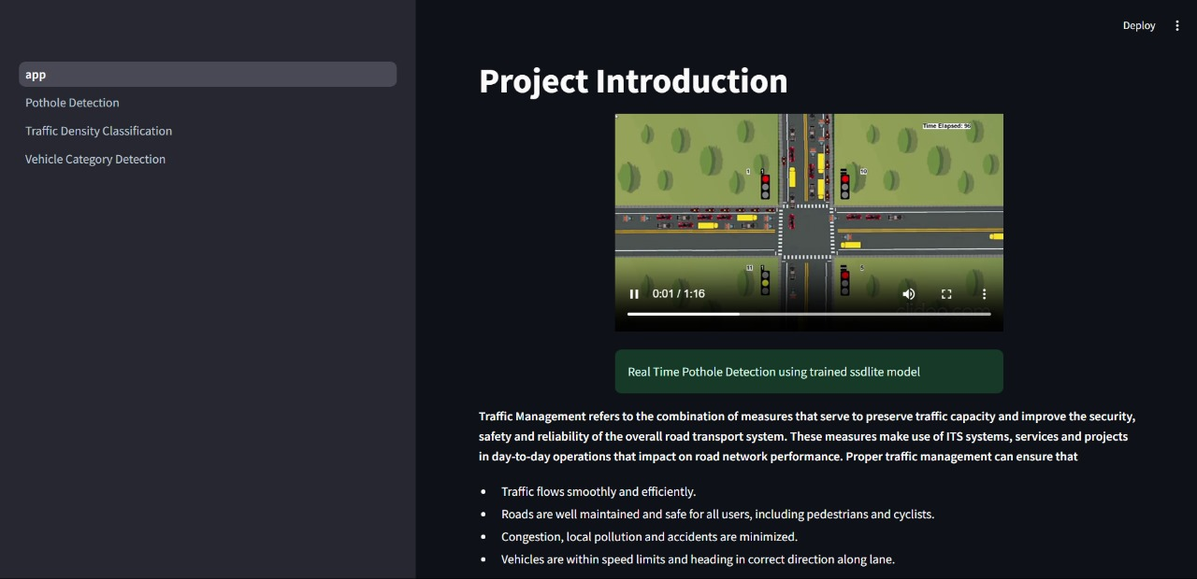

**Fig. 3. App Introduction**

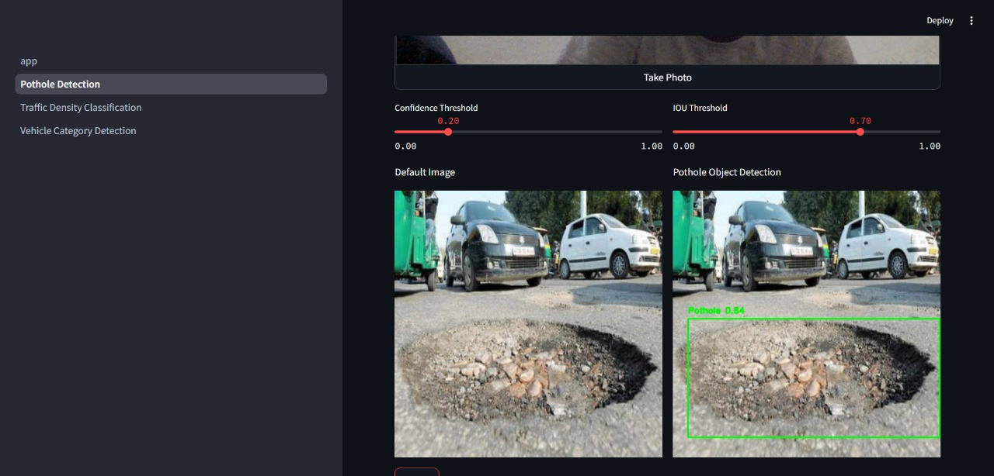

**Fig. 4. Pothole detection**

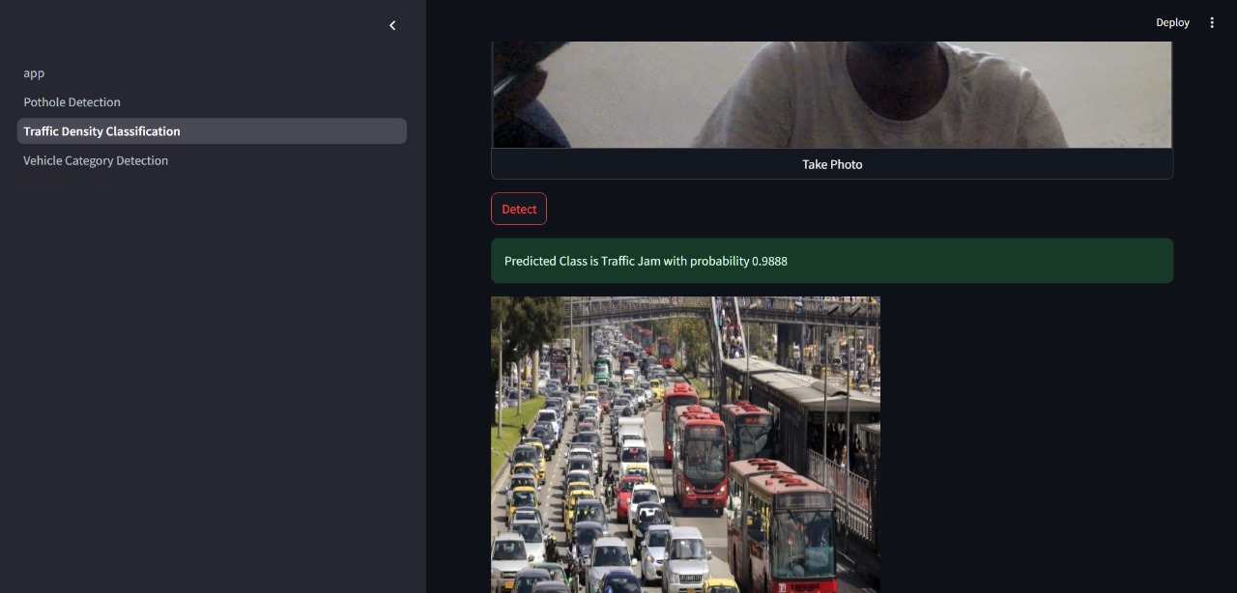

**Fig. 5. Traffic Density Classification**

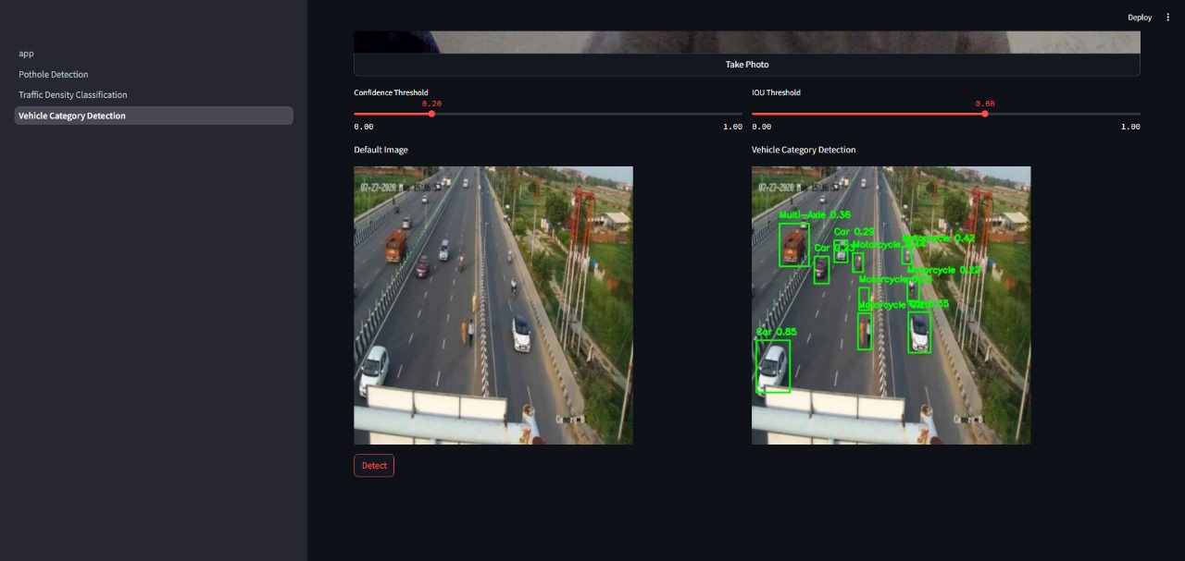

**Fig. 6. Vehicle Category Detection**

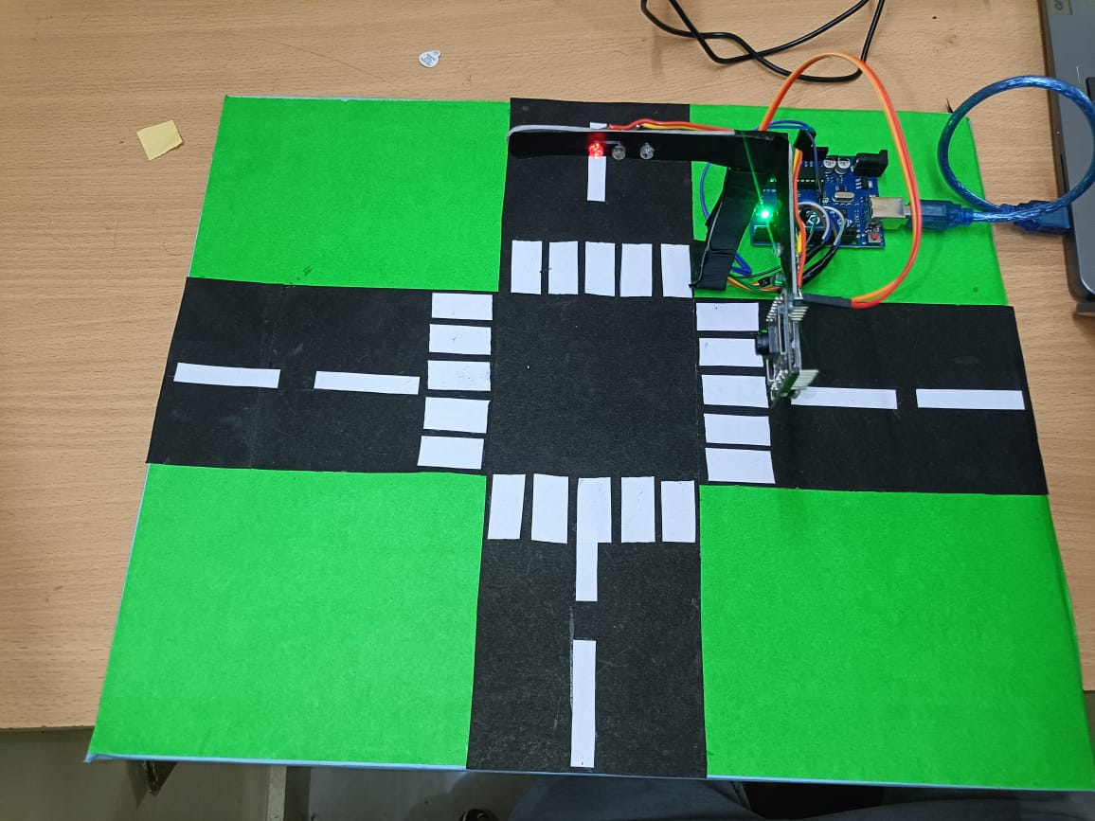 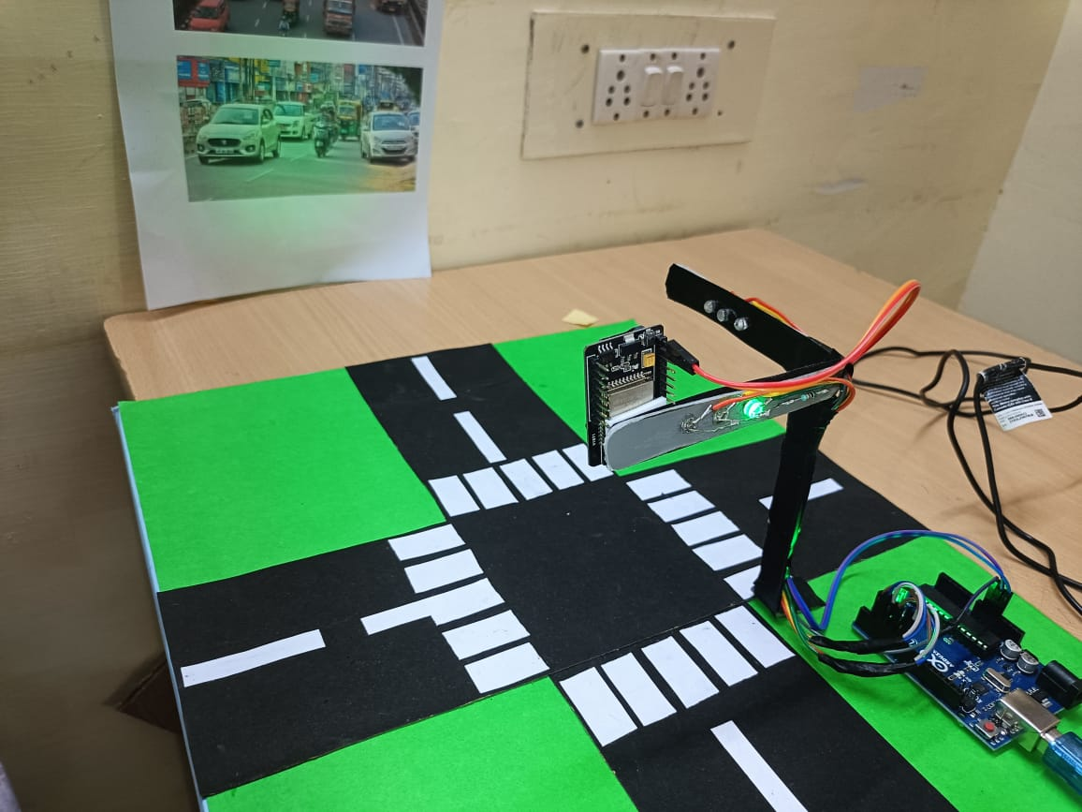

**Fig. 7. prototype**

**CHAPTER-VIII**

**COMMUNITY IMPACT**

Implementing an advanced AI-powered Traffic Signal Management System has a profound positive impact on communities. By improving traffic flow, enhancing safety, and reducing environmental impact, this system directly contributes to a higher quality of life in urban and suburban areas. Here are some ways in which this technology benefits communities:

1. **Reduced Commute Times and Increased Productivity**:
   * Efficient traffic management reduces congestion and minimizes delays at intersections, resulting in shorter commute times for residents.
   * By spending less time in traffic, people have more time for personal, family, and professional activities, contributing to increased productivity and overall life satisfaction.
   * Reduced commute times also alleviate stress associated with long periods of waiting and driving in heavy traffic, improving mental well-being.
2. **Environmental Benefits and Health Improvements**:
   * The adaptive signal timing reduces idling times and the frequency of stop-and-go traffic, leading to lower fuel consumption and reduced vehicle emissions.
   * Cleaner air and reduced greenhouse gas emissions contribute to better respiratory health for the community, especially for children, elderly residents, and those with pre-existing health conditions.
   * By supporting sustainability initiatives and lowering the community's carbon footprint, the system aligns with global environmental goals and enhances public health outcomes.
3. **Enhanced Safety for Drivers and Pedestrians**:
   * The system’s use of real-time object detection and adaptive timing improves intersection safety by reducing the likelihood of accidents caused by sudden stops, rear-end collisions, and running red lights.
   * By prioritizing the safe passage of emergency vehicles through automated "Green Corridors," response times are improved, potentially saving lives in critical situations and enhancing community safety.
   * Future system integrations could include pedestrian detection to adjust signals based on foot traffic, making it safer for pedestrians and cyclists to navigate busy intersections.
4. **Economic Benefits for Local Businesses**:
   * Faster and more efficient transportation allows local businesses to operate more effectively, as employees, goods, and customers reach their destinations without excessive delays.
   * Reduced transportation costs (e.g., lower fuel costs) can benefit businesses with delivery and logistics operations, making it easier for companies to manage their operations and save money.
   * Additionally, an efficient transportation system makes the community more attractive for new businesses, fostering local economic growth and creating job opportunities.
5. **Improved Public Transportation Efficiency**:
   * When adapted for multimodal use, this system can prioritize public transit vehicles, reducing delays and making public transportation a more attractive option for residents.
   * Enhanced public transit flow reduces reliance on private vehicles, potentially lowering overall traffic congestion and making the city more accessible for residents of all socioeconomic backgrounds.
   * Better public transportation contributes to a more inclusive community, where everyone has access to efficient and affordable mobility options.
6. **Empowering a Smart, Sustainable Community**:
   * The use of AI and real-time data analytics in traffic management contributes to the development of a "smart city" infrastructure, helping the community become more connected and data-driven.
   * The reduction in traffic-related emissions and idling aligns with sustainable development goals and fosters community pride in eco-friendly initiatives.
   * A smart transportation infrastructure signals to residents and businesses that the community is forward-thinking, adaptable, and committed to using technology to solve urban challenges.
7. **Community Engagement and Awareness**:
   * The visibility of an AI-powered, efficient traffic management system raises awareness about technology’s role in improving daily life, potentially inspiring community members, especially young people, to pursue education and careers in STEM fields.
   * Educating the community on how traffic management systems work, including their environmental and economic benefits, can foster greater appreciation and understanding of local government efforts to improve infrastructure.
8. **Enhanced Quality of Life**:
   * Ultimately, improved traffic flow, cleaner air, increased safety, and reduced commute times contribute to a higher quality of life for community members.
   * By transforming the way people move within the city, this system supports a healthier, safer, and more enjoyable environment for all residents.

**CHAPTER-IX**

**CONCLUSION AND FUTURE SCOPE**

The implementation of a smart, AI-powered Traffic Signal Management System represents a significant advancement in addressing the critical issues of traffic congestion, prolonged commute times, increased fuel consumption, and environmental pollution in urban areas. By leveraging real-time data, advanced object detection algorithms, and adaptive signal timing, this system brings an innovative solution to traditional traffic management challenges.

The adaptive nature of the system, powered by technologies such as YOLO for object detection, enables precise categorization and counting of vehicles, which helps tailor signal timings dynamically to current traffic conditions. This approach not only improves traffic flow by reducing unnecessary stops but also minimizes idling, which in turn leads to lower fuel consumption and reduced emissions. Additionally, the prioritization of emergency vehicles through an automated "Green Corridor" improves response times for critical services, potentially saving lives and enhancing public safety.

Through the integration of machine learning, this system continuously learns from historical and real-time data, allowing for improved decision-making over time. As a result, the AI-driven traffic signal management system offers a highly effective, adaptable, and sustainable solution to the challenges of modern urban traffic, aligning with broader goals for smarter, safer, and greener cities.

**Future Scope**

While the current implementation of AI-powered traffic signal management addresses many pressing issues, there are numerous opportunities for future enhancement and expansion. Here are some areas where the system could be further developed:

1. **Integration with Autonomous and Connected Vehicles**:
   * As autonomous vehicles become more common, traffic signal management systems could be designed to communicate directly with these vehicles, allowing for more precise and coordinated traffic flow.
   * Vehicle-to-Infrastructure (V2I) communication could enable real-time data exchange, facilitating seamless signal adjustments and allowing autonomous vehicles to plan routes more efficiently.
2. **Expansion to Multimodal Transportation Systems**:
   * Future systems could integrate data from various transportation modes, including buses, bicycles, and pedestrian flows. This would allow for more inclusive signal timing adjustments that take into account the needs of all road users, not just motor vehicles.
   * Smart traffic systems could also prioritize public transportation, providing dedicated green signals to buses during peak hours, thus encouraging public transit use and reducing congestion.
3. **Enhanced Hazard Detection and Pedestrian Safety**:
   * Advanced AI models could be developed to detect not only vehicles but also pedestrians, cyclists, and other potential hazards. Future systems might adjust signal timings to ensure safer intersections for vulnerable road users.
   * Incorporating additional sensors and cameras could improve detection accuracy, leading to even better safety measures at intersections.

**REFERENCES**

1. Zhang, C., Patil, A., Virdi, A., Luján, M., & Shah, S. (2020). Deep Learning-Based Pothole Detection and Classification Using Cameras. Sensors, 20(15), 4319.
2. Badrinarayanan, V., Kendall, A., & Cipolla, R. (2017). SegNet: A Deep Convolutional Encoder-Decoder Architecture for Image Segmentation. IEEE Transactions on Pattern Analysis and Machine Intelligence.
3. Canny, J. (1986). A Computational Approach to Edge Detection. IEEE Transactions on Pattern Analysis and Machine Intelligence.
4. Liu, W., Anguelov, D., Erhan, D., Szegedy, C., Reed, S., Fu, C. Y., & Berg, A. C. (2016). SSD: Single Shot MultiBox Detector. In European conference on computer vision (ECCV)
5. Redmon, J., & Divvala, S. (2016). You Only Look Once: Unified, Real-Time Object Detection. In Proceedings of the IEEE Conference on Computer Vision and Pattern Recognition (CVPR).
6. Zheng, H., Xie, L., Wang, L., & Yu, Y. (2019). Real-Time License Plate Recognition for Intelligent Transportation Systems. IEEE Transactions on Intelligent Transportation Systems, 21(8), 3364-3373.
7. Girshick, R. (2015). Fast R-CNN. In Proceedings of the IEEE international conference on computer vision (ICCV).
8. Redmon, J., & Farhadi, A. (2018). YOLOv3: An Incremental Improvement. arXiv:1804.02767.
9. Tan, M., & Le, Q. V. (2019). EfficientNet: Rethinking Model Scaling for Convolutional Neural Networks. In International Conference on Machine Learning (ICML).
10. He, K., Gkioxari, G., Dollár, P., & Girshick, R. (2017). Mask R-CNN. In Proceedings of the IEEE international conference on computer vision (ICCV)